The following written Hazard Communication Program has been established for (Name and location of Company) ___________________________________________________________. All divisions and sections of the company are included within the program. The written program will be available in (location) ____________________________ for review by any interested employee.

(Name of Company) ________________________ will meet the requirements of this
regulation as follows:

1. Container Labeling:

(Person/position) _________________ will verify that all containers received for use will be provided with:

a. Product identifier
b. Signal word
c. Hazard statement(s)
d. Pictogram(s)
e. Precautionary statement(s); and
f. Name, address, and telephone number of the chemical manufacturer, importer, or other responsible party

2. Solid Material Labeling
(Person/position) _______________ will verify that all solid materials not exempted due to their downstream use; were delivered with a label or received the label prior to the initial shipment, and need not be included in subsequent shipments unless information on the label changes.

(Person/position) ________________ at each work site will ensure that all secondary containers are labeled with either an extra copy of the original manufacturer’s label, or with our company’s own labels which have the requirements of the original label or, product identifier, words, pictures, symbols or combination thereof, which provide at least general information regarding the hazards of the chemicals. For help with labeling contact the safety/health officer who is ______________________________.

Additional Guidance for Secondary Labeling:
https://www.osha.gov/dsg/hazcom/hazcom-faq.html
The current standard provides employers with flexibility regarding the type of system to be used in their workplaces and OSHA has retained that flexibility in the revised Hazard Communication Standard (HCS). Employers may choose to label workplace containers either with the same label that would be on shipped containers for the chemical under the revised rule, or with label alternatives that meet the requirements for the standard. Alternative labeling systems such as the National Fire Protection Association (NFPA) 704 Hazard Rating and the Hazardous Material Identification System (HMIS) are permitted for workplace containers. However, the information supplied on these labels must be consistent with the revised HCS, e.g., no conflicting hazard warnings or pictograms.

3. Safety Data Sheets (SDS)

Copies of the SDSs for all hazardous chemicals to which employees of this
Company may be exposed will be in (Location) _____________________ and
(Location)________________________ .

SDSs will be available to all employees in their work area for review during
each work shift. If SDSs are not immediately available or new chemicals
in use do not have an SDS, please immediately contact (person/position)
_______________________ .

4. Employee Training and Information

Prior to starting work each new employee of (name of company) __________
_______________ will attend a safety and health orientation and will receive
information and training on the following:

a. An overview of the requirements contained in the Hazard Communication
standard, Section 1910.1200. This includes the labeling requirements under Global Harmonization System (GHS).
b. Chemicals present in the workplace operations.
c. Location and availability of our written hazard communication program, including our list of hazardous chemicals, and safety data sheets.
d. Physical, health, simple asphyxiation, combustible dust, and pyrophoric gas hazards, as well as hazards not otherwise classified, of the chemicals in the work area.
e. Methods and observation techniques used to determine the presence or release of hazardous chemicals in the work area.
f. How to lessen or prevent exposure to these hazardous chemicals through usage of control/work practices and personal protective equipment.
g. Steps the company has taken to lessen or prevent exposure to these chemicals.
h. Safety emergency procedures to follow if they are exposed to these chemicals.
i. How to read labels on shipped containers, as well as workplace labeling systems and review SDSs format and how to obtain appropriate hazard information.

It is advisable to keep documentation of training on file, as evidence of training may be requested by the U.S. or State of Maine Department of Labor, or Assistant Secretary of Labor may be requested. Documentation should include topic, date, person conducting training and attendance roster. Employees should sign the training roster to verify they attended the training, received our written materials, and understood (name of company) ____________________’s policies on hazard communication.

Prior to a new hazardous chemical being introduced into any section of this company, each employee of that section will be given information as outlined above. (Person/position) _____________________ is responsible for ensuring that SDSs on the new chemical(s) are available.

5. List of Hazardous Chemicals

The following is a list of all known hazardous chemicals used by employees of (name of company) ________________________. Further information on each noted chemical can be obtained by reviewing SDSs located in/at (location) ____________ and (location) ___________________.

HAZARDOUS CHEMICALS WORK PROCESS WHERE USED
____________________________ _____________________________
____________________________ _____________________________
____________________________ _____________________________
____________________________ _____________________________
____________________________ _____________________________

NOTE: The hazard communication standard only requires a list of all hazardous chemicals; however, it is felt that identifying the location and possible processes will aid the employer in carrying out the full program.

6. Hazardous Non-routine Tasks

Occasionally, employees are required to perform hazardous non-routine tasks. Prior to starting work on such given projects, each affected employee will be given information by their supervisor about hazardous chemicals to which they may be exposed during such activity.
This information will include:

a. Specific chemical hazards
b. Protective/safety measures the employee can take
c. Measures the company has taken to lessen the hazards including ventilation, respirators, presence of another employee, and emergency procedures.
Examples of non-routine tasks performed by employees of this company are:
TASK HAZARDOUS CHEMICAL
_____________________ ___________________________________
_____________________ ___________________________________
_____________________ ___________________________________
_____________________ ___________________________________
_____________________ ___________________________________

7. Chemicals in Unlabeled Pipes

Work activities are often performed by employees in areas where chemicals are transferred through unlabeled pipes.
Prior to starting work in these areas, the employee must contact __________
(person/position) for information regarding:
a. The chemicals in the pipes
b. Potential hazards
c. Safety precautions which should be taken
8. Informing Contractors
It is the responsibility of (person/position)___________________ to provide contractors (with employees) the following information:
a. SDSs for hazardous chemicals to which they may be exposed while on the work site.
b. Precautions the employees may take to lessen the possibility of exposure by usage of appropriate protective measures.
c. The labeling system used in the work place.

LIST OF HAZARDOUS CHEMICALS AND INDEX OF SDSs
NAME OF COMPANY ___________________________

HAZARDOUS CHEMICAL OPERATION/AREA USED SDS ON FILE
_______________________ _______________________ _____________
_______________________ _______________________ _____________
_______________________ _______________________ _____________
_______________________ _______________________ _____________
_______________________ _______________________ _____________
_______________________ _______________________ _____________
_______________________ _______________________ _____________
_______________________ _______________________ _____________
_______________________ _______________________ _____________
_______________________ _______________________ _____________
_______________________ _______________________ _____________
_______________________ _______________________ _____________
_______________________ _______________________ _____________
_______________________ _______________________ _____________
_______________________ _______________________ _____________
_______________________ _______________________ _____________
_______________________ _______________________ _____________
_______________________ _______________________ _____________
_______________________ _______________________ _____________
_______________________ _______________________ _____________
_______________________ _______________________ _____________
_______________________ _______________________ _____________
_______________________ _______________________ _____________
_______________________ _______________________ _____________
_______________________ _______________________ _____________
_______________________ _______________________ _____________
_______________________ _______________________ _____________
_______________________ _______________________ _____________

EMPLOYER’S RECORD OF EMPLOYEES TRAINED
AS PART OF HAZARD COMMUNICATION REQUIREMENT

CHEMICALS FOR WHICH
EMPLOYEE SIGNATURE TRAINING GIVEN
________________________________ _____________________________
________________________________ _____________________________
________________________________ _____________________________
________________________________ _____________________________
________________________________ _____________________________ ________________________________ _____________________________
________________________________ _____________________________ ________________________________ _____________________________ ________________________________ _____________________________ ________________________________ _____________________________ ________________________________ _____________________________ ________________________________ _____________________________ ________________________________ _____________________________
________________________________ _____________________________
________________________________ _____________________________
________________________________ _____________________________
________________________________ _____________________________
________________________________ _____________________________
________________________________ _____________________________
________________________________ _____________________________
________________________________ _____________________________ ________________________________ _____________________________ ________________________________ _____________________________
________________________________ _____________________________ ________________________________ _____________________________ ________________________________ _____________________________ ________________________________ _____________________________ ________________________________ _____________________________ ________________________________ _____________________________ ________________________________ _____________________________ ________________________________ _____________________________ ________________________________ _____________________________ ________________________________ _____________________________ ________________________________ _____________________________ ________________________________ _____________________________ ________________________________ _____________________________
Date of Training __________ Signature of Trainer ________________________

Format of SDS’s as part of Global Harmonization System
Section 1, Identification includes product identifier; manufacturer or distributor name, address, phone number; emergency phone number; recommended use; restrictions on use.
Section 2, Hazard(s) identification includes all hazards regarding the chemical; required label elements.
Section 3, Composition/information on ingredients includes information on chemical ingredients; trade secret claims.
Section 4, First-aid measures includes important symptoms/ effects, acute, delayed; required treatment.
Section 5, Fire-fighting measures lists suitable extinguishing techniques, equipment; chemical hazards from fire.
Section 6, Accidental release measures lists emergency procedures; protective equipment; proper methods of containment and cleanup.
Section 7, Handling and storage lists precautions for safe handling and storage, including incompatibilities.
Section 8, Exposure controls/personal protection lists OSHA's Permissible Exposure Limits (PELs); Threshold Limit Values (TLVs); appropriate engineering controls; personal protective equipment (PPE).
Section 9, Physical and chemical properties lists the chemical's characteristics.
Section 10, Stability and reactivity lists chemical stability and possibility of hazardous reactions.
Section 11, Toxicological information includes routes of exposure; related symptoms, acute and chronic effects; numerical measures of toxicity.
Section 12, Ecological information*
Section 13, Disposal considerations*
Section 14, Transport information*
Section 15, Regulatory information*
Section 16, Other information, includes the date of preparation or last revision.
*Note: Since other Agencies regulate this information, OSHA will not be enforcing Sections 12 through 15(29 CFR 1910.1200(g)(2)).

Pictograms
Health Hazards
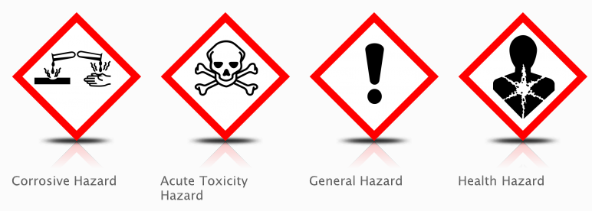
Environmental Hazards
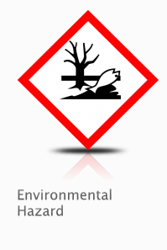
Physical Hazards
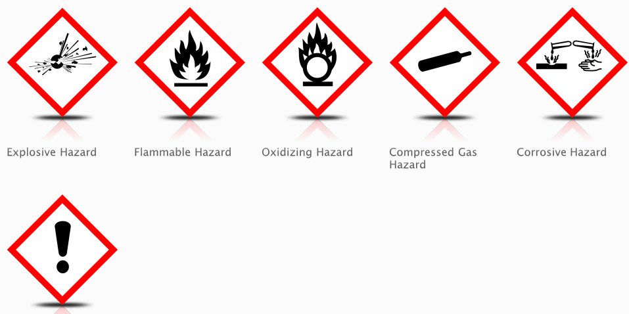

Transportation Hazards
