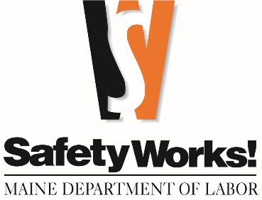
FREE TRAINING

Incident Investigation/Injury Analysis |  | November 4
Thorough root cause investigations and trend analysis are paramount to prevent future injuries and illnesses. In this class, you will learn how to perform a thorough investigation, interview employees, determine root causes, implement systemic corrective measures, and analyze data to prevent future events. An interactive, hands-on investigation helps participants practice new concepts.
Wage & Hour Compliance | Rockland | November 5
This course is designed for human resource or benefits professionals, accountants, business owners, managers, or payroll supervisors. Labor laws can be complex. This seminar covers wage and hour laws, including minimum wage, overtime, youth employment, severance pay, equal pay, rest breaks, leave requirements (earned paid leave, family medical leave, family sick leave and leave for victims of violence). This class addresses commonly asked labor-related questions.
10-Hour Construction Standards |  | November 6 & 7
This one-and-a-half-day course teaches hazard identification and controls on a variety of construction industry safety and health topics (29 CFR 1926). This is an entry-level course and attendees who complete this course will receive an OSHA 10-hour course completion certificate.
Lead Safety |  | November 10
This half-day course provides information on OSHA's Lead Standards for Construction and General Industry (1926.62 and 1910.1025). The information obtained in this lead safety program helps you understand the standards and lower your risk for illness related to lead exposure.
Cold Illness Prevention |  | November 13
Whether your employees work outside in the winter or inside in cold storage facilities, cold temperatures pose a hazard to your workers. This class covers cold temperature illnesses, signs and symptoms, and control measures to prevent and treat cold-related injuries.
The Maine Department of Labor offers safety and health and labor law classes—at no charge.
November 2025 CLASSES
(all in Augusta unless indicated otherwise)

Automotive Lift & Jack Stands Safety and Compliance |  | November 18
This half-day course provides training on the proper operation of multiple types of automotive lifts, jacks and jack stands, inspection, compliance reporting, training, and documentation required by various inspecting agencies. The course will provide the information needed for a safer workplace, which helps eliminate citations and can possibly lower a company's workers’ compensation insurance expense. The course will have classroom and hands-on training.
Scaffolding & Fall Protection |  | November 19
Falls are one of the leading causes of death and injury in the workplace. This course provides the construction and general industry standards that regulate walking-working surfaces, including scaffolding, and the fall protection control measures that are available to protect your employees.
Impairment Detection Training for Employers |  | November 20
This one-day training session is designed to help owners, managers, and supervisors recognize and respond appropriately to employee-impairment in the workplace to reduce worker accidents and injuries. Participants will be taught procedures to detect impairment regardless of the substance or cause. This class is designed to fulfill the federal DOT requirements for reasonable suspicion training of supervisors. In addition, participants will learn how to develop and implement policies that address impairment in the workplace and are in compliance with Maine's Substance Use Testing Law.

Call 207-623-7900 to enroll • TTY users call Maine Relay 711
Maine Department of Labor, Bureau of Labor Standards
45 State House Station, Augusta, ME 04333-0045
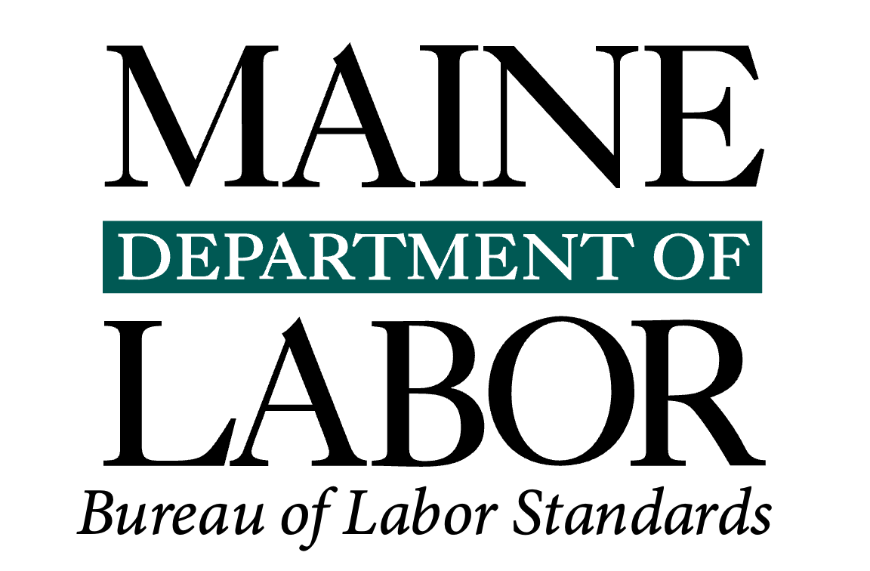

Visit our website at safetyworksmaine.gov for a complete list of classes.
The Maine Department of Labor provides equal opportunity in employment and programs.
Auxiliary aids and services are available to individuals with disabilities upon request.

Register and browse more SafetyWorks! classes: https://www.safetyworksmaine.gov/training/scheduled_classes/register.shtml

If you have questions about safety or upcoming classes, reach out to SafetyWorks! at 1-877-SAFE-345 or general.bls-safetyworks@maine.gov.

If you have questions about Wage and Hour compliance, please reach out to the Wage and Hour Division at 207-623-7900 or bls.mdol@maine.gov, or visit www.maine.gov/labor/bls/.

