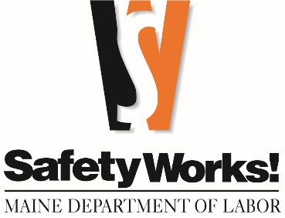
FREE TRAINING

Wage & Hour Compliance | Brewer | October 1
This course is designed for human resource or benefits professionals, accountants, business owners, managers, or payroll supervisors. Labor laws can be complex. This seminar covers wage and hour laws, including minimum wage, overtime, youth employment, severance pay, equal pay, rest breaks, leave requirements (earned paid leave, family medical leave, family sick leave and leave for victims of violence). This class addresses commonly asked labor-related questions
Bloodborne Pathogens Train-the-Trainer |  | October 2
Half-day class provides guidance on what is needed to be compliant with the bloodborne pathogen standard. This course will review written program requirements, training, documentation, Hepatitis B, and sharp logs.
Wage & Hour Compliance | Lewiston | October 15
This course is designed for human resource or benefits professionals, accountants, business owners, managers, or payroll supervisors. Labor laws can be complex. This seminar covers wage and hour laws, including minimum wage, overtime, youth employment, severance pay, equal pay, rest breaks, leave requirements (earned paid leave, family medical leave, family sick leave and leave for victims of violence). This class addresses commonly asked labor-related questions.
Workstation Ergonomics – Video Display Terminal |  | October 16
Employees computer workstations should be designed to reduce the potential for musculoskeletal injuries. This course reviews Maine's VDT law, its requirements, reviews the hazards of improper workstation setup, and provides hands-on practice of evaluating and modifying workstations.
Cold Illness Prevention |  | October 17
Whether your employees work outside in the winter or inside in cold storage facilities, cold temperatures pose a hazard to your workers. This class covers cold temperature illnesses, signs and symptoms, and control measures to prevent and treat cold-related injuries.
The Maine Department of Labor offers safety and health and labor law classes—at no charge.
october 2025 CLASSES
(all in Augusta unless indicated otherwise)

NFPA #1 Fire Code |  | October 21
This one-day course provides overview training for fire fighters and emergency response personnel. This multi-part document has 16 sections to safeguard life and protect property from dangerous conditions caused by fire and explosion. Other fire codes including NFPA 101, 57, 58, 30, 13, 25, and 72 are referred to in this code.

Fire Extinguisher/EAP/Workplace Violence |  | October 22
Workplace emergencies include fire, medical, and workplace violence. This course covers the requirements of an emergency action plan, fire extinguisher use, and considering the potential for workplace violence. The SWTI Lab includes a fire extinguisher discharge activity to assist participants in learning how to use a fire extinguisher.
OSHA Recordkeeping | Brewer | October 23
This class provides thorough and comprehensive six-hour training for both new and experienced safety and human resources personnel. You will learn the OSHA rule (29 CFR 1904) regarding recording and reporting work-related injuries and illnesses as it applies to your organization, including COVID-19 recordability guidance. This class includes several hands-on activities on how to correctly fill out the required injury reporting forms.
Welding/Compressed Gas |  | October 27
This class covers the requirements of the welding standard, in addition to the storage and proper use of compressed gas. Proper inspection techniques of hoses, torches, and regulators will be demonstrated.
Safety & Health Management Systems |  | October 28
Successful safety and health programs are more than just compliance with the OSHA standards. Injuries and illnesses are reduced when employers possess common elements to identify and address safety and health hazards. This course outlines roles and responsibilities, common principles, required functions and programs of a successful safety and health management system. This course prepares organizations who would like to pursue SHARP/ SHAPE.
Wage & Hour Compliance | Freeport | October 29
This course is designed for human resource or benefits professionals, accountants, business owners, managers, or payroll supervisors. Labor laws can be complex. This seminar covers wage and hour laws, including minimum wage, overtime, youth employment, severance pay, equal pay, rest breaks, leave requirements (earned paid leave, family medical leave, family sick leave and leave for victims of violence). This class addresses commonly asked labor-related questions.
Impairment Detection Training for Employers |  | October 30
This one-day training session is designed to help owners, managers, and supervisors recognize and respond appropriately to employee-impairment in the workplace in order to reduce worker accidents and injuries. Participants will be taught procedures to detect impairment regardless of the substance or cause. This class is designed to fulfill the federal DOT requirements for reasonable suspicion training of supervisors. In addition, participants will learn how to develop and implement policies that address impairment in the workplace and are in compliance with Maine's Substance Use Testing Law.

Call 207-623-7900 to enroll • TTY users call Maine Relay 711
Maine Department of Labor, Bureau of Labor Standards
45 State House Station, Augusta, ME 04333-0045
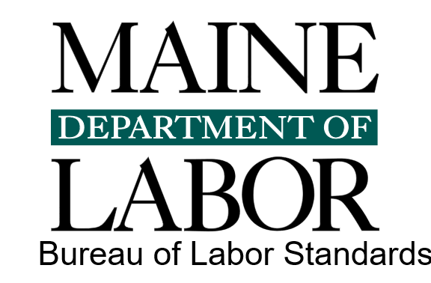

Visit our website at safetyworksmaine.gov for a complete list of classes.
The Maine Department of Labor provides equal opportunity in employment and programs.
Auxiliary aids and services are available to individuals with disabilities upon request.

Register and browse more SafetyWorks! classes: https://www.safetyworksmaine.gov/training/scheduled_classes/register.shtml

If you have questions about safety or upcoming classes, reach out to SafetyWorks! at 1-877-SAFE-345 or general.bls-safetyworks@maine.gov.

If you have questions about Wage and Hour compliance, please reach out to the Wage and Hour Division at 207-623-7900 or bls.mdol@maine.gov, or visit www.maine.gov/labor/bls/.

