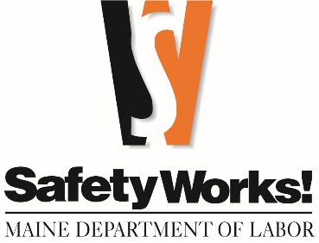
FREE TRAINING

Emergency Scene Traffic Control | Virtual | September 9
This class covers requirements for training, personal protective equipment (PPE) for firefighters and Emergency Medical Service (EMS) providers who will be controlling traffic at unplanned motor vehicle accidents. This program will also include setting up a safe work-zone, equipment needed, guidance for day and nighttime operations, blocking to protect the scene, apparatus parking, incident types, signs, communication regulatory text, liability and more.
Vehicle Ergonomics |  | September 10
Program participants will have an improved understanding of the importance of proper driving posture, varying work activities, stretching and activity breaks, limiting exposures, and how to make regular corrective adjustments to driving positions.
Wage & Hour Compliance | Biddeford | September 10
This course is designed for human resource or benefits professionals, accountants, business owners, managers, or payroll supervisors. Labor laws can be complex. This seminar covers wage and hour laws, including minimum wage, overtime, youth employment, severance pay, equal pay, rest breaks, leave requirements (earned paid leave, family medical leave, family sick leave and leave for victims of violence). This class addresses commonly asked labor-related questions.
Safety and the Supervisor |  | September 11
The success of any safety program is dependent on your front-line supervisors. Do they have the technical and interpersonal skills it takes to move your safety program in a positive direction? This training discusses the interpersonal skills all supervisors should develop to create a positive safety culture. In addition, the course will outline the key tasks supervisors should be performing daily to identify hazards and keep their employees safe.
Lifting & Rigging Safety |  | September 12
Lift planning is essential to safe-lifting practices. This program will explore lifting and rigging equipment, inspections, signaling, and planning for safe lifts.
The Maine Department of Labor offers safety and health and labor law classes—at no charge.
September 2025 CLASSES
(all in Augusta unless indicated otherwise)

Monitoring & Evaluating for Air and Noise Hazards |  | September 16
Employers are required to identify and evaluate air and noise hazards in the workplace. This course provides the terminology, screening and monitoring equipment and techniques, and compares data to standards to determine appropriate control measures.

Wage & Hour Compliance |  | September 17
This course is designed for human resource or benefits professionals, accountants, business owners, managers, or payroll supervisors. Labor laws can be complex. This seminar covers wage and hour laws, including minimum wage, overtime, youth employment, severance pay, equal pay, rest breaks, leave requirements (earned paid leave, family medical leave, family sick leave and leave for victims of violence). This class addresses commonly asked labor-related questions.
Life Safety Code 101 |  | September 18
This one-day class will provide a working overview of the National Fire Protection Association (NFPA) Standard 101 "Life Safety Code" for fire and life safety in the building environment. The topics covered will include classification of occupancy types, adequate means of egress, occupant load factors, and occupancy specific hazards to fire and life safety. The Life Safety Code is adopted in the State of Maine as the state code for fire and life safety in buildings.
Trenching & Excavation |  | September 19
This course explains the dangers to employees from trenching and excavation operations, soil classifications, OSHA requirements, and the types of protective systems to prevent cave-ins. You will also learn what is meant by "competent person".
Preventing Musculoskeletal Injuries |  | September 23
Musculoskeletal (MSK) injuries can be a challenge to recognize as they often come on gradually from repetitive use. Other times these injuries are related to sprain or strain. In any event, MSKs make up the most injuries we see in the workplace. In this session you will learn: The importance of matching employee fitness to the essential physical demands of a job, evaluate a job looking to prevent MSK risks, how to successfully develop and implement a custom workplace stretching and strengthening program that improves flexibility and reduces strain and strain severity and incidence, to properly respond to employees' early symptoms and provide effective first aid intervention that alleviates fear, prevents a disability mindset, and promotes recovery.
Wage & Hour Compliance | Rockland | September 24
This course is designed for human resource or benefits professionals, accountants, business owners, managers, or payroll supervisors. Labor laws can be complex. This seminar covers wage and hour laws, including minimum wage, overtime, youth employment, severance pay, equal pay, rest breaks, leave requirements (earned paid leave, family medical leave, family sick leave and leave for victims of violence). This class addresses commonly asked labor-related questions.

Work Zone Safety |  |  | September 29
Private companies and public agencies that work on public roads must follow the traffic control standards of the Manual on Uniform Traffic Control Devices (MUTCD). This hands-on, half-day course covers the MUTCD standards and use of cones, signs, flags, and paddles.
Respiratory Protection |  | September 30
Where workers are required to wear respirators to do their jobs, employers need a respiratory protection program. This course helps you determine your respiratory protection needs and covers all the elements of a written respiratory protection program.

Call 207-623-7900 to enroll • TTY users call Maine Relay 711
Maine Department of Labor, Bureau of Labor Standards
45 State House Station, Augusta, ME 04333-0045
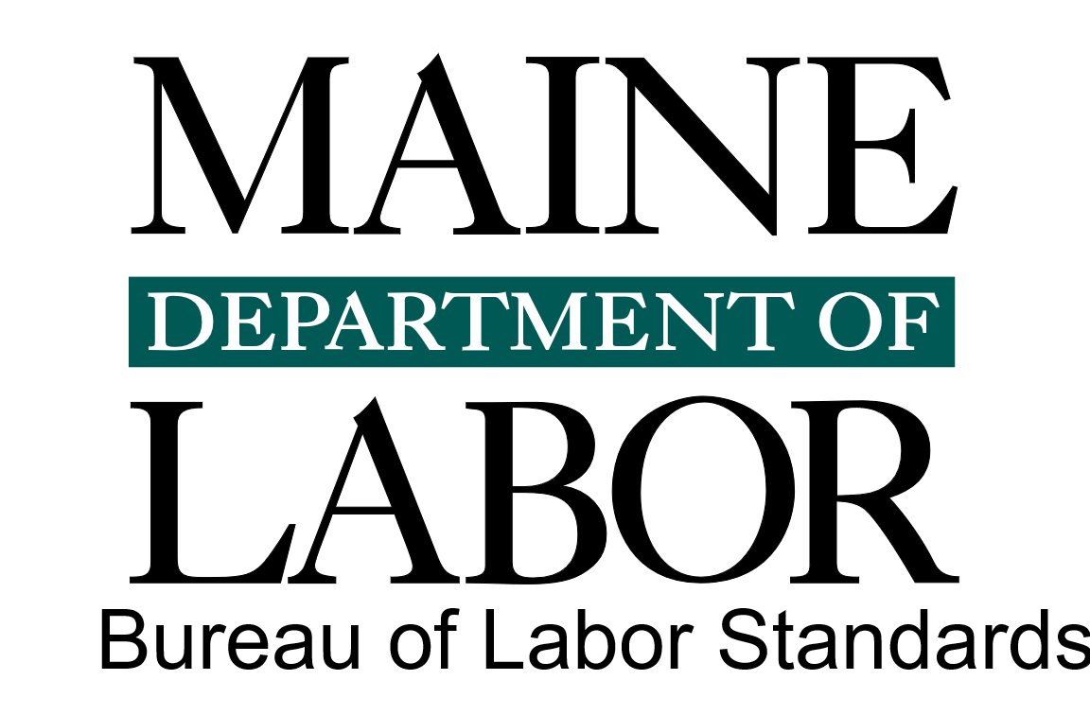

Visit our website at safetyworksmaine.gov for a complete list of classes.
The Maine Department of Labor provides equal opportunity in employment and programs.
Auxiliary aids and services are available to individuals with disabilities upon request.

Register and browse more SafetyWorks! classes: https://www.safetyworksmaine.gov/training/scheduled_classes/register.shtml

If you have questions about safety or upcoming classes, reach out to SafetyWorks! at 1-877-SAFE-345 or general.bls-safetyworks@maine.gov.

If you have questions about Wage and Hour compliance, please reach out to the Wage and Hour Division at 207-623-7900 or bls.mdol@maine.gov, or visit www.maine.gov/labor/bls/.

